Warn your family! Clear the spare room, teach your pets to be careful, set up barricades and put
Force-o-rama is about to rule your house!
up CAUTION signs! You do not want anyone to bump your contraption or they might just set off a chain reaction of unpredictable events

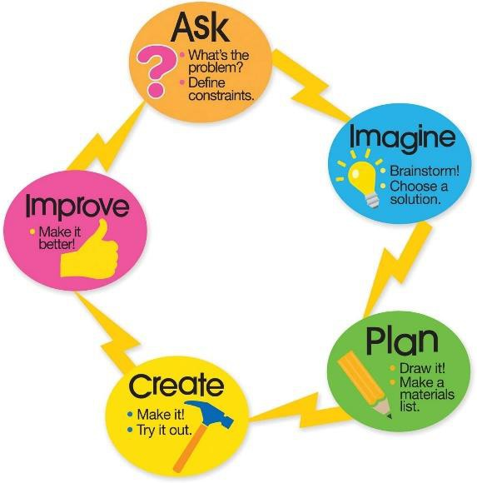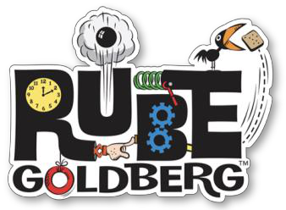

Over the next two weeks, you will be working through a challenge inspired by the inventor Rube Goldberg. You will build your own contraption to help you solve a problem you’re facing at home or to help you complete a task.
The challenge: Can you create a four (or more!) step machine to help you complete an everyday task in isolation by only touching the contraption once yourself.

Make a Force-o-rama demonstrating at least three forces in action.

You will be working through the Engineering Design Process to help you complete this task.

In Week 9, you will be working through stage 1 – 3 (Ask, Imagine and Plan) and in Week 10 you will get stuck into the final stages of Create and Improve. Finally, at the end of Week 10 we will share.

You can work by yourself, with a sibling or you can even get the big kids (aka your parents) involved in the fun too!

The Planning Template

You will use the ‘Force-o-rama’ template to track your progress.

I recommend printing this out if you have access to a printer. You will find the template at the end of this document. Or if you are mainly working on OneNote, you can view the document and complete your work on blank paper or in a book you already have at home, alternatively, create a new page in your UOI folder to store your work. There will be some sketching involved throughout the process so a pencil and paper is recommended for some of the steps.

Week 9 Sequence of Activities

Stage 1 - Ask questions:

What is the problem? Are there any challenges?

Think about a problem to be solved or something that you want to make a contraption to do for you. Make a list of 10 problems to solve/things that you could use a machine to help you do.

For Example:
• Your sibling keeps leaving your door open – create an automatic door closer.
• Your dog keeps annoying you to be let in/out of the house – create an automatic door opener.
• You need to pass the sugar – create a sugar passer.
• You have to feed the pets each night – create a pet feeding machine.
• You’re sick of turning the pages in your book – create a page turner

List your problems that you want to make a contraption to solve

Then, think about the challenges you might face in creating that machine: For Example:
• I don’t have a dog, so there is no point in me creating a contraption to feed my dog
• My parent/siblings are working in the kitchen so I’ll need to build this somewhere else.

List possible challenges you might face

Finally, select the problem that you want build a contraption to help you to solve and record your work on the Force-o-rama template (Separate document)

Stage 2- Imagine it: Look for some inspiration and brainstorm your ideas. Pick the best one!

Record your work on the Force-o-rama template

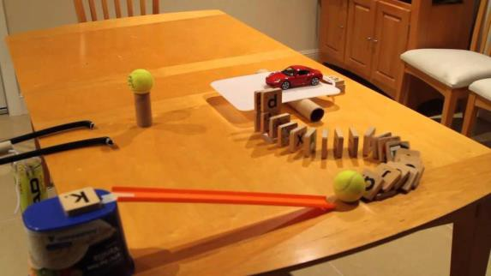Finding inspiration for your contraption is going to be very easy to do. This stage is all about getting excited and collecting ideas. You will find videos and photos of things you might be able to try out.

Record them so that you don’t lose them!

You can do a simple Google search by typing: ‘Rube Goldberg machine’ – click images

There are also endless examples of Rube Goldberg Machines on YouTube – just be careful to keep on topic in your search and make sure an adult approves how much time you spend watching videos for inspiration!

Check your UOI folder for the page titled Rube Inspiration for direct links to these clips:

Jo seph’s M achines – YouTube Chanel
How to Pass The Pepper While Social Distancing
How to Pass the Salt While Maintaining Proper Social Distance
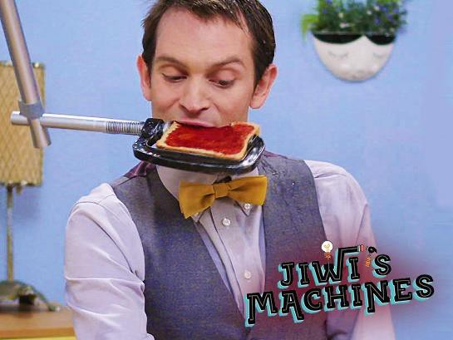250,000 Dominoes - The Incredible Science Machine: GAME ON! OK Go - This Too Shall Pass - Rube Goldberg Machine - Official Video
The Swish Machine (Elaborate basketball swish)

Whilst all of those are AMAZING! You might need to start with something simpler. Remember, your machine only needs 3 steps.

Beginner friendly ideas:
Rube Goldberg easy examples (dog feeder) Rube Goldberg Ideas (single step ideas)
Rube Goldberg Machine (candle putter outer – with bloopers)

Stage 3 - Plan it: Make a list of materials you will use. Draw a diagram with labels.
Record your work on the Force-o-rama template
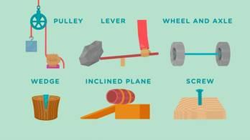
After learning about the 6 different types of simple machines in Reading this week, you should be beginning to get some ideas of how you will bring your contraption to life and the things around the house you might need.

You are now going to start creating a plan for your contraption. You need to:

• Create a list of the things you want to use and begin collecting them
• Draw you contraption - Include labels of the materials, simple machines and forces you want to include
• Don’t forget to start thinking of a name for your machine

You might also like to start testing out small components of you plan to see how they go by themselves.
Week 10 Sequence of Activities.

You will have this week to finalise your ideas so don’t rush. It is recommended that you work through 1 of the
stages per day when UOI is in the schedule.
Feel free to dedicate extra time to make your contraption as extravagant as you want.

Stage 4 - Create it: Follow your plan. Create a model.

• Begin putting together the pieces of your machine.
• Take some photos along the way and track your progress.
• Don’t lose sight of your overall plan of what you actually want your machine to do – e.g. open/close the door
• Check that you have included at least 3 steps.

Tips for Success

1. Success breeds enthusiasm, so keep the steps to a minimum.

You can always add more as you go.

2. Ask your family for ideas and input
3. Work collaboratively
4. Have fun!

Stage 5 - Improve it: Did it work? Can you make it better? What could be done differently?

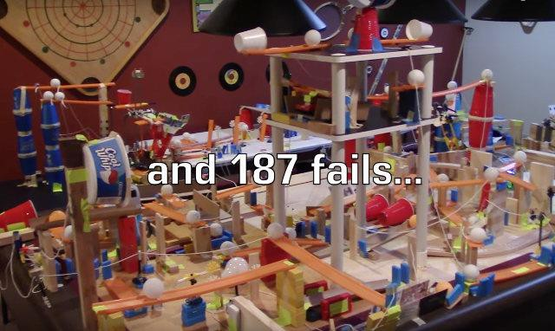No doubt through the creation and testing of your machine you’ve made many adjustments and improvements make sure you’ve recorded them down in the Force-o-rama template

A Note on Failure
As you test and try out different set-ups, you’ll undoubtedly fail a few times. But this is great news! Failure is a piece of the invention process, and without these mistakes we won’t learn how things really work. So embrace failure and celebrate it as part of the learning process.

Share it: What changes need to be made? What do others think?

I have prepared a collaborative PowerPoint document available to you via Teams meeting.
Your teacher will put the link into your classes PowerPoint OneNote Content Library – Rube Goldberg PowerPoint

Access the PowerPoint and add the following information to the slide that has your name on it:

• The name of your contraption
• A photo or short video of your contraption (less than 1min)
• A list of the forces, simple machines used, or steps involved

While you are working in the document you must only work on your slide. You need to be very careful not to go on to another students slide or you may disrupt or even delete their work!

